Turner Up Hill Champs (FRA Junior Fell Champs Round 6) 20/06/15

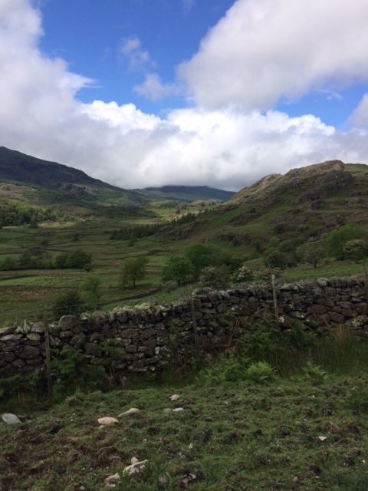 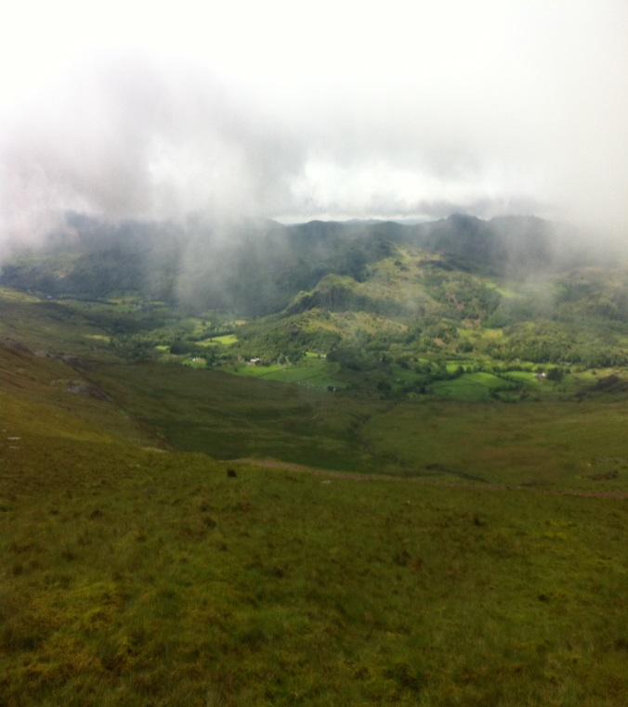

The 2015 FRA Fell season came to a close with the final round (6) being held in the dramatic setting of the Duddon Valley. Once again the event was a well organised event hosted by Broughton Runners. After the “character building” conditions last year anything less than a tsunami this year would be a significant improvement. 15 JIH’s made it across to the start line with 11 juniors taking the opportunity to camp with their parents in the fantastically beautiful Turner Hill campsite situated just 500m from the start. After arrival in sunny conditions we all got our tents up/vans sorted and we all made our way to the pub for some “pre-race planning” For the JIH’s this consisted of getting some decent solid food down whilst the adults appeared to be more concerned with liquid refreshment! After returning to the campsite a couple of nightcaps were taken before everyone got their heads down for hopefully a good night’s sleep. As it traditional at the Turner Uphill race we awoke to driving rain lashing the tent. After breakfast in wet conditions we took a stroll across to registration where a full kit check took place before the juniors were allowed to race.

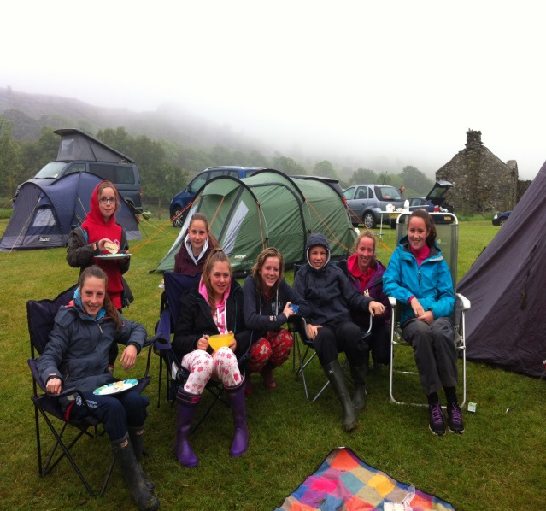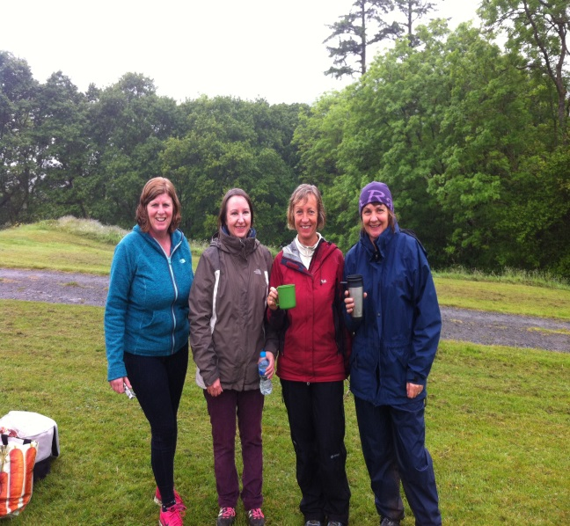

The U8/U10’s ran a slightly different course running up and down the track leading to Seathwaite tarn. All other age groups ran up the really rough Walna Scar track to finish at different points on the accent. The U16 is finishing at the Walner Scar summit ( 420M) and the U18s turning left at this point a continuing to the summit of Brown Pike (465m) . The incessant rain continued through all the races and typically as the U18 finished the sun broke through, the mist cleared and the whole valley was bathed in brilliant sunshine. On the really challenging routes all JIH’s took on the accent with typical enthusiasm and we had a number of good performances with top 5 finishes for Robyn & Poppy Anderson, Euan Brennan & Lucy Williamson

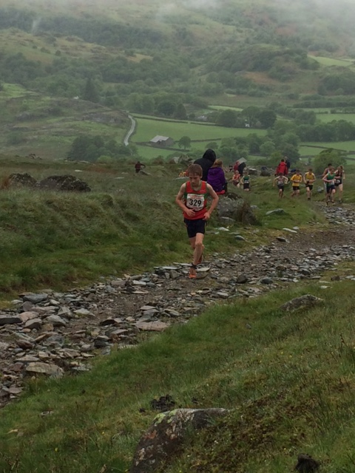 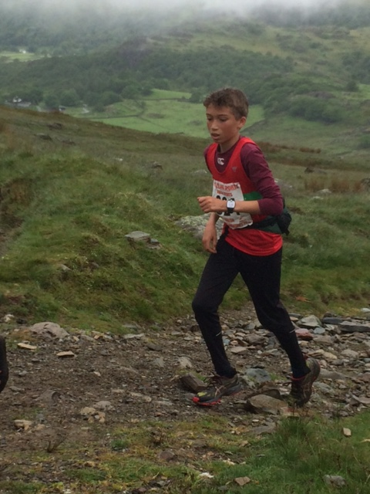

Full results

BU 8 Max Stead 17th

GU10 Robyn Anderson 5th BU10 Archie Budding 12th, George Morley 13th

GU12 Poppy Anderson 4th, BU12 Harry Stead 29th.

GU14 Beth Morley 10th Emily Elmes 15th, Ella Shouler – Harris 16th BU14 Euan Brennan 3rd, Robbie Matthews 11th,  Reuben Foster 27th

GU16 Lucy Jacques 10th

GU18 Lucy Williamson 4th , Joanne Williamson 8th.

Final Series Results

During the season 25 JIH’s took part in at least one Championship race this season with a number completing all 6.

U8/U10 deemed “no competitive infants” and results for series not recorded apart from number of races completed, therefore -

BU8 Max Stead 4 , Jonathon Archer 1,

GU10 Robyn Anderson 6 , Archie Budding 3, Dylan Carr 2, George Morley 1.

U12/14/16/18 Series positon (number of races)

GU12 Poppy Anderson 6th (6) Lyra Weston 28th ( 3) BU12 Lewis Carr 13th (4) Harry Stead 34th (4) Ben Morley 65th (1)

GU14 Ella Shouler- Harris 25th (3) Emily Elmes 26th (3) Beth Morley 39th (1) BU Euan Brennan 5th (6) Robbie Matthews 14th (6) Reuben Foster 54th (1)

GU16 Jemima Elgood 2nd (5) Sarah Pickering 5th (4) Lucy Jacques 12th (5) Lucy Haines 27th (2) Nea Weston 28th (3)

GU18 Lucy Williamson 4th (6) Joanne Williamson 5th (5) BU 18 Ruaridh Mon- Williams 19th (1)

Lucy and Joanne Williamson competed as part of the JIH squad for the last time this year before racing as seniors next season. They have been ever presents over the past few years and are always to be seen actively encouraging the younger athletes on the Fells. On behalf of all thanks for your support and all the very best for next year. Don’t be strangers to your friends in the squad, you will always be welcomed back with open arms.

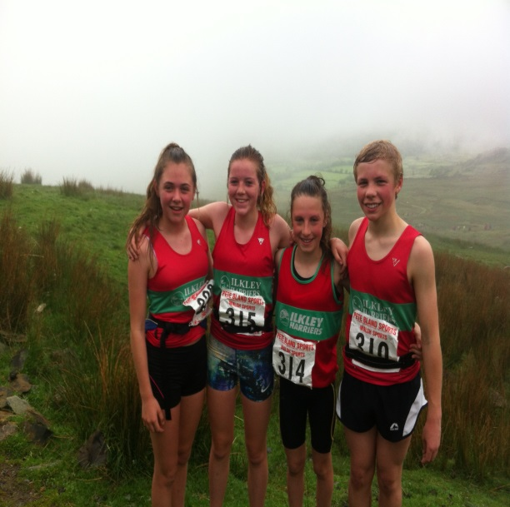 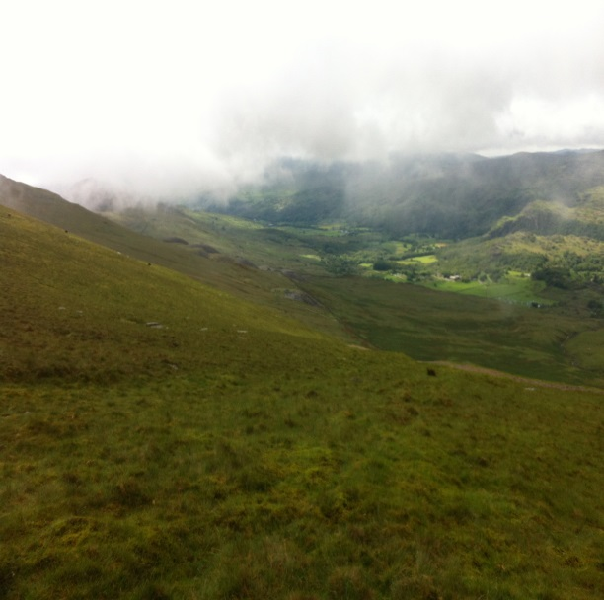

After the races the normal fun and games took place around the start including a number of JIH’s taking the opportunity of an “ice bath” in the stream

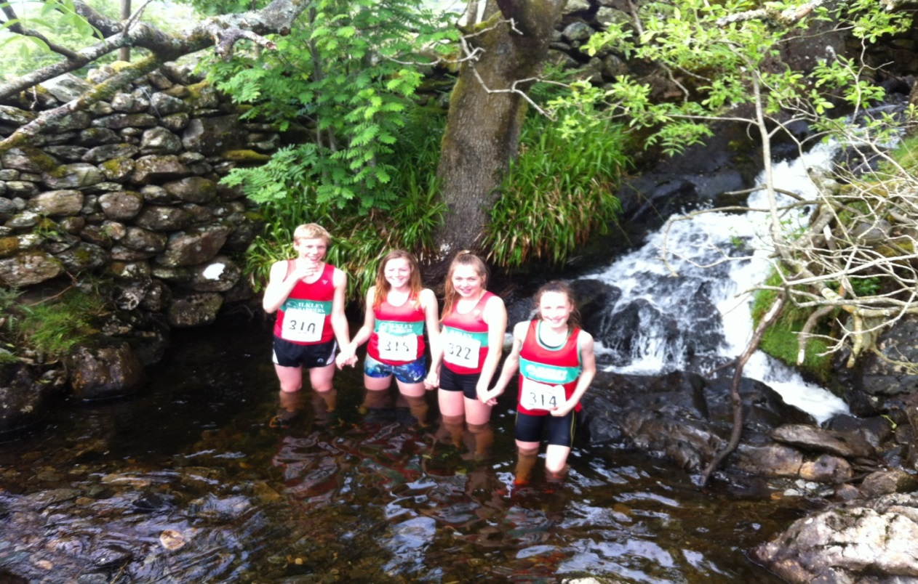

One significant disappointment on the day however was for the Senior Ilkley ladies “Cake Squad” (Kate, Sue & Julie) getting caught up in supporting their kids racing so much that the buns were sold out by the time they got there. 3 very disappointed ladies as they have extensively “tested” numerous buns & cakes up and down the country all year. (Never mind Ladies, better planning required next time round :-))

After the races we all headed back to the campsite in glorious warm sunshine with the whole valley lit up for some food and few drinks. A really relaxing evening was had by all sat outside as the sun went down. Special thanks to the Morley’s for hosting the evening BBQ outside their van. Outstanding contribution from Lee “Heston Blumenthal” Morley for his creative Cheese, biscuit, Revel’s, and Spicy pork pie combo. A taste bud sensation and wonderful after a few pints!!!

As a club this seasons target was to improve on our best ever result last year of 4th. MISSION ACCOMPLISHED!!!! I am pleased to report that we finished joint **2nd** out of nearly 60 clubs competing! 2nd most successful Junior fell club in the country is a massive accomplishment for every JIH that competed in an English Championship race this season.

Whilst the FRA season has finished the Fell season continues with BOFA races all through the summer and the final Woodentops Fell races taking place in October/December. If you have never tried a fell race I encourage you to give it a try. Its great fun and the camaraderie in our Fell Squad is acknowledged by many other Clubs who have commented how much our juniors support each other and clearly enjoy the events. If you give it a go you will be warmly welcomed by all, give it a bash and I am sure you will return for more.

On behalf of everyone associated with Ilkley, well done to every one of you that ran in a championship race this year, we are all so proud of your commitment, dedication and effort.

Joint 2nd this year & improving every year in the last 4, next year’s target is …………………….. ☺